Home/Lifestyle/People

# Young lodgers bring joy to elderly nursing home residents’lives

By Liu Mingtai and Zhou Huiying|China Daily|Updated:2024-01-22 06:24

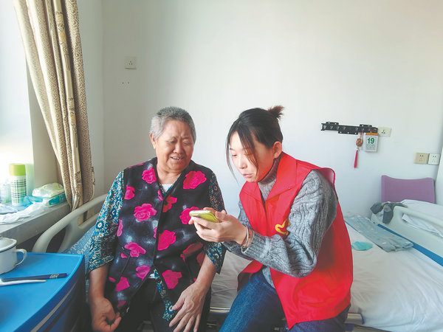A volunteer teaches a senior to use the smartphone at the Xiyangfu Nursing Home in Jilin city,Jilin province.[Photo provided to China Daily]

After his final exam on Jan 11,Wang Yatao immediately moved into the Xiyangfu Nursing Home in Jilin city,Jilin province,becoming a special lodger among the group of seniors.

The 22-year-old sophomore at the Jilin Agricultural Science and Technology University decided to spend two weeks at the nursing home before returning to his hometown in Yingtan city,Jiangxi province.

“I was attracted by a short video posted on(video-sharing platform)Douyin in early January,”he says.“In the video,the owner of the nursing home was recruiting young people as lodgers.”

People who are younger than 35 and have a college education can get a single room,three meals a day and a monthly stipend of 300 yuan($42)with a requirement to do 20 hours of volunteer service during that period.

Applicants should have a fixed job or study in college,and should not drink or smoke.

“In fact,what attracted me was not the small stipend but rather,the volunteer service,”says Wang.“I thought it would be a good opportunity to have a different kind of volunteer experience.”

Wang has participated in the volunteer team since he enrolled in the university.

“We initiated various volunteer activities across the city,such as visiting nursing homes,tutoring impoverished and‘left-behind’children of migrant workers,and teaching the public about environmental protection,”he says.

“But I have never lived with so many seniors and delved so deeply into their lives.”

Zhou Weihong,owner of the nursing home,hopes to build a platform for both the elderly and youth.

“Lots of young people have to leave their hometowns and relatives for study or work,so they may miss the chance to live with their families,especially their grandparents,”says the 60-year-old.

“Living in my nursing home will enable them to better understand and communicate with the elderly.And these younger people can bring new things and vitality to the elderly residents,who are…much happier when their grandchildren visit.”

Zhou’s post recruiting lodgers has racked up over 1 million hits since he put it online in early January.

“I received hundreds of applications,”he says.“After careful screening,I chose six,all of whom are college students from the cities of Jilin,Changchun and Baicheng.

“They will spend about two weeks of vacation before the Spring Festival in the nursing home,”he says,adding that another 10 will come after the festival.

Zhou’s nursing home opened in 2004 and houses around 100 seniors,aged from 50 to 100.

“There are 30 workers taking care of their daily lives,so I don’t worry about labor,”he says.“I just hope the volunteers will provide quality companionship.”

Zhou says a growing proportion of the population is elderly,especially in the northeast.

“I hope young people will be able to alleviate their loneliness,understand their difficulties and deepen their awareness while respecting and loving the elderly,”he says.

Over 280 million Chinese,accounting for nearly 20 percent of the population,were above 60 years old by the end of 2022,according to the Ministry of Civil Affairs.A further 210 million people,or almost 15 percent,are 65 or older.

Wang says he and the other volunteers have spent the last few days presenting performances,painting pictures and exercising with the seniors.

“I spent almost all of my time during the day with them.It was a really different vacation,”he says.

“It gives me a warm feeling.They treat us like their grandchildren,and share their fruit and snacks with us.I’ll continue to visit after I return to my university in the spring semester.And I’ll spread the word about this among our volunteer team.”

年轻的寄宿者给养老院的老年居民带来了快乐

2024年1月22日，中国日报报道：刘明泰、周慧英



一位志愿者在吉林市西洋府养老院教一位老人使用智能手机。【图片来源：中国日报】

1月11日期末考试结束后，22岁的大二学生王亚涛立即搬进了吉林市西洋府养老院，成为老年群体中的特殊寄宿者。

这位吉林农业科技大学的学生决定在回到江西省鹰潭市的家乡之前，在养老院度过两个星期。

他说：“我被1月初在抖音（视频分享平台）上发布的一个短视频所吸引。在视频中，养老院的负责人正在招募年轻人作为寄宿者。”

年龄在35岁以下且具有大学学历的人可以获得单人间、每日三餐以及每月300元（42美元）的生活津贴，同时需要在此期间提供20小时的志愿服务。

申请者应该有一份稳定的工作或在大学学习，并且不应该饮酒或吸烟。

王亚涛说：“实际上，吸引我的并不是那笔小小的津贴，而是志愿服务。我认为这是一个有机会获得不同种类志愿经历的好机会。”

自从他入学以来，王亚涛就一直参与志愿者团队。

他说：“我们在城市中发起了各种志愿活动，如探访养老院、辅导农民工贫困和留守儿童，以及向公众普及环境保护知识。”

“但我从未和这么多老人一起生活过，也从未如此深入地了解过他们的生活。”

养老院的负责人周卫红希望为老年人和年轻人建立一个平台。

他说：“许多年轻人不得不离开家乡和亲人去学习或工作，因此他们可能错过与家人，尤其是祖父母一起生活的机会。”

“在我的养老院生活将使他们更好地理解和与老年人交流。这些年轻人可以给老年居民带来新鲜事物和活力，当他们的孙辈来访时，老年人会更加快乐。”

周卫红在1月初将招募寄宿者的帖子发布在网上后，点击量已经超过100万次。

他说：“我收到了数百份申请。经过仔细筛选，我选择了六位寄宿者，他们都是来自吉林、长春和白城的大学生。”

他说：“他们将在春节前的两个星期在养老院度过假期。”他还补充说，春节过后还会有另外10位寄宿者到来。

周卫红的养老院于2004年开业，目前居住着大约100位年龄在50至100岁之间的老人。

他说：“有30名工作人员负责照顾他们的日常生活，所以我不担心劳动力问题。我只希望志愿者能够提供优质的陪伴。”

周卫红表示，老年人在人口中所占比例越来越大，尤其是在东北地区。

他说：“我希望年轻人能够减轻他们的孤独感，理解他们的困难，并在尊重和爱护老年人的同时加深他们的意识。”

根据民政部的数据，截至2022年底，中国超过2.8亿人年满60岁，占人口的近20%。另外2.1亿人，即将近15%，年满65岁或以上。

王亚涛说，他和其他志愿者过去几天一直陪伴老人表演、绘画和锻炼身体。

他说：“我几乎整天都和他们在一起。这是一个非常不同的假期。这让我感到温暖。他们把我们当作他们的孙辈，与我们分享水果和零食。我将在春季学期回到大学后继续探访他们。我还会在我们的志愿者团队中传播这个消息。”